**EEE 431 TELECOMMUNICATIONS I**

**MATLAB ASSIGNMENT II**

Efe Eren CEYANİ

21903359

EEE 431-01

**INTRODUCTION**

In this MATLAB assignment, our aim was to experiment with digital modulation methods and examine the behavior of white Gaussian noise in a digital environment. Digital modulation is ideal for telecommunications due to its advantages over analog modulation. There are several digital modulation methods and depending on the application, an optimal one can be found. However, even though they have their differences, the receiver design is similar in each modulation technique. In this assignment, we found basis vectors for correlators and decision rules to minimize the estimation error.

To test the digital modulation techniques and check whether a receiver design is optimal or not, we use the most basic channel model, the additive white Gaussian noise (AWGN) channel model. In order to simulate AWGN model, the behavior of white Gaussian in a digital environment is critical because it is impossible to generate an ideal one. One must know the effects of limiting the bandwidth of the white noise to measure error probabilities and signal-to-noise ratios (SNR) properly.

**Part I: Signal Spaces**

(a)

The dimension of the signal space is 30 because we need three basis vectors for each k so that we guarantee that the signal is represented in the signal space.

The basis vectors are in the following form:

|  |  |  |
| --- | --- | --- |
|  |  |  |
|  |  |  |

The coefficient normalizes each vector. Also, inner product of two distinct basis vectors results in 0, which is desired.

(b)

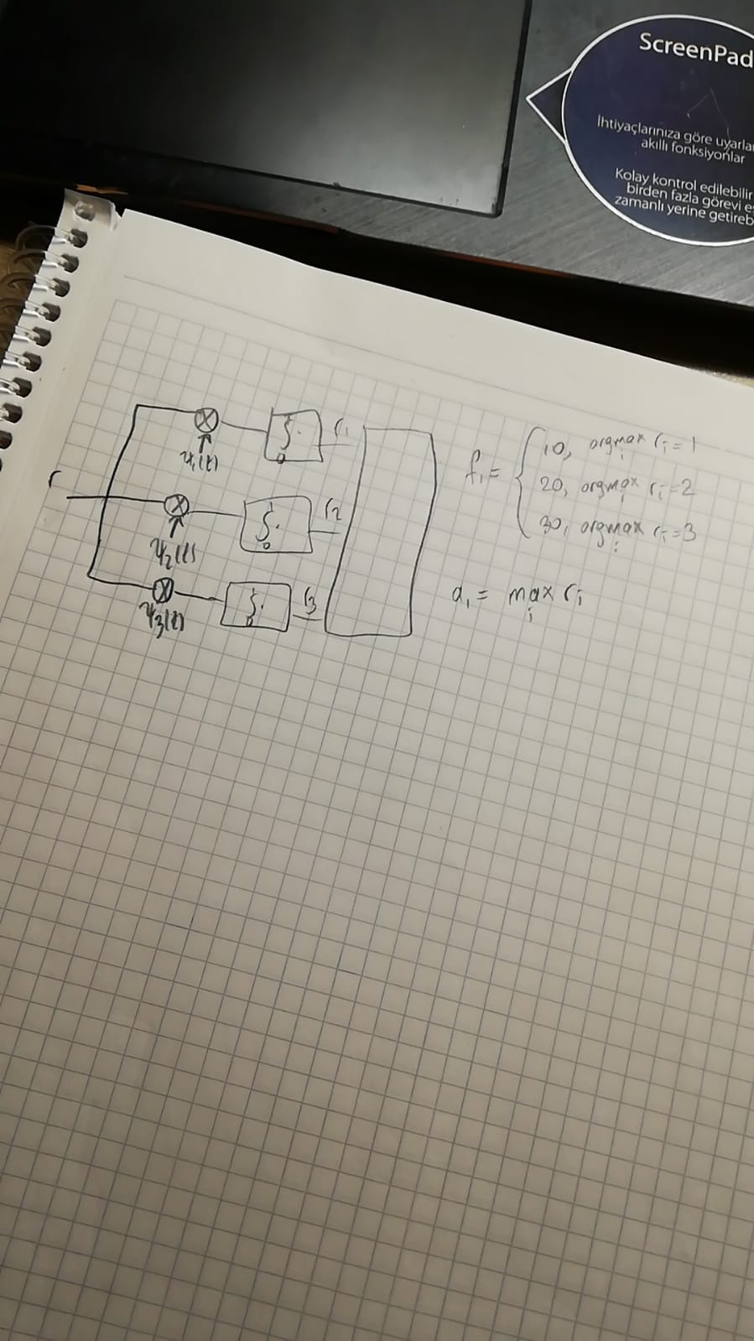

Figure 1.1.1 Technique to estimate ak and fk for k = 1.

The receiver design in Figure 1.1.1 can be also applied for all k’s. After performing the receiver for each value of k, we will gather the values of ak and fk.

In Figure 1.1.1, the amplitude is found for the theoretical case. In MATLAB, we must scale the amplitudes because we are working in a digital environment rather than a continuous one.

(c)

|  |  |  |  |  |  |  |  |  |  |
| --- | --- | --- | --- | --- | --- | --- | --- | --- | --- |
| 1 | 2 | 3 | 4 | 5 | 6 | 7 | 8 | 9 | 10 |
| 30 | 50 | 80 | 120 | 150 | 160 | 190 | 230 | 250 | 300 |

Figure 1.2.1 Estimated frequency values for each k (First row: k, second row: values).

|  |  |  |  |  |  |  |  |  |  |
| --- | --- | --- | --- | --- | --- | --- | --- | --- | --- |
| 1 | 2 | 3 | 4 | 5 | 6 | 7 | 8 | 9 | 10 |
| 10 | 2 | 10 | 2 | 2 | 1 | 8 | 2 | 5 | 9 |

Figure 1.2.2 Estimated amplitude values for each k (First row: k, second row: values).

The estimated amplitude values are rounded up because they were too many repeating decimals.

(d)



Figure 1.3.1 The original and the perturbed signal, variance is 1.



Figure 1.3.2 The original and the perturbed signal, variance is 25.



Figure 1.3.3 The original and the perturbed signal, variance is 100.

(e)

|  |  |  |  |  |  |  |  |  |  |
| --- | --- | --- | --- | --- | --- | --- | --- | --- | --- |
| 1 | 2 | 3 | 4 | 5 | 6 | 7 | 8 | 9 | 10 |
| 30 | 50 | 80 | 120 | 150 | 160 | 190 | 230 | 250 | 300 |

Figure 1.4.1 Estimated frequency values for each k, variance is 1.

|  |  |  |  |  |  |  |  |  |  |
| --- | --- | --- | --- | --- | --- | --- | --- | --- | --- |
| 1 | 2 | 3 | 4 | 5 | 6 | 7 | 8 | 9 | 10 |
| 9.9884 | 1.9257 | 9.9940 | 1.9641 | 2.0279 | 1.0047 | 8.0475 | 1.9538 | 4.9638 | 9.0594 |

Figure 1.4.2 Estimated amplitude values for each k, variance is 1.

|  |  |  |  |  |  |  |  |  |  |
| --- | --- | --- | --- | --- | --- | --- | --- | --- | --- |
| 1 | 2 | 3 | 4 | 5 | 6 | 7 | 8 | 9 | 10 |
| 30 | 50 | 80 | 120 | 150 | 160 | 190 | 230 | 250 | 300 |

Figure 1.4.3 Estimated frequency values for each k, variance is 25.

|  |  |  |  |  |  |  |  |  |  |
| --- | --- | --- | --- | --- | --- | --- | --- | --- | --- |
| 1 | 2 | 3 | 4 | 5 | 6 | 7 | 8 | 9 | 10 |
| 10.0763 | 1.8369 | 10.1405 | 2.3137 | 1.9459 | 1.0666 | 8.0078 | 2.0780 | 5.2798 | 8.7106 |

Figure 1.4.4 Estimated amplitude values for each k, variance is 25.

|  |  |  |  |  |  |  |  |  |  |
| --- | --- | --- | --- | --- | --- | --- | --- | --- | --- |
| 1 | 2 | 3 | 4 | 5 | 6 | 7 | 8 | 9 | 10 |
| 30 | 50 | 80 | 110 | 150 | 160 | 190 | 230 | 250 | 300 |

Figure 1.4.5 Estimated frequency values for each k, variance is 100.

|  |  |  |  |  |  |  |  |  |  |
| --- | --- | --- | --- | --- | --- | --- | --- | --- | --- |
| 1 | 2 | 3 | 4 | 5 | 6 | 7 | 8 | 9 | 10 |
| 9.3369 | 1.7874 | 9.6378 | 0.3284 | 1.3880 | 1.4631 | 8.1580 | 1.8494 | 4.9823 | 8.7055 |

Figure 1.4.6 Estimated amplitude values for each k, variance is 100.

Discussion: As the variance increases, the estimation error in amplitude increases significantly. However, for the frequencies, only one of them was estimated incorrectly when the variance was 100. It is harder to estimate frequencies incorrectly because incorrect frequencies’ correlations are just made out of noise, which has zero-mean.

**Part II: Binary Modulation**

(a)



Figure 2.1.1 Signal generated from the bits: 00001.

(b)



Figure 2.2.1 The basis vector of the signal space

The dimension of the signal space is 1 because two signals are just the negative versions of each other.



Figure 2.2.2 First signal represented in the signal space



Figure 2.2.3 Second signal represented in the signal space

(c) Blue lines: Original signal Orange lines: Perturbed signal



Figure 2.3.1 The original and the perturbed signal, variance is 0.0001.



Figure 2.3.2 The original and the perturbed signal, variance is 0.01.



Figure 2.3.3 The original and the perturbed signal, variance is 1.

Discussion

Theoretically, the SNR is given as Es/N0. However, this definition is only true for an ideal white noise process. Since we are not able to cover the whole spectrum of the noise, depending on the sampling rate, the spectral density of the white Gaussian noise will be bandlimited. The exact amount is Fs/2, where Fs is the sampling rate. So, as long as we increase the sampling rate, the SNR will go up because the spectral density is N0B/2, where B is the bandwidth of the spectral density.

(d)

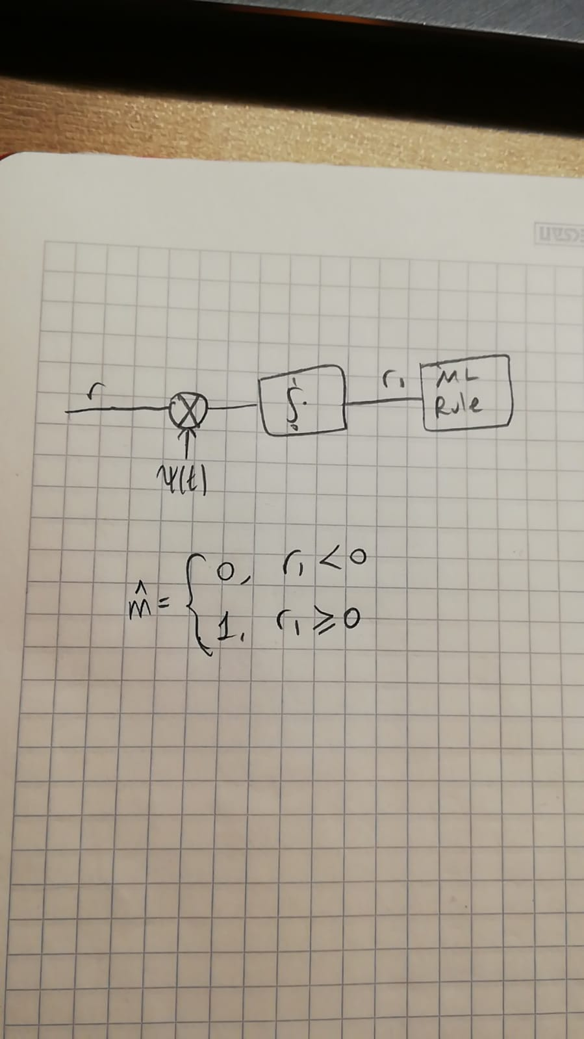

Figure 2.4.1 The optimal receiver and the ML rule.

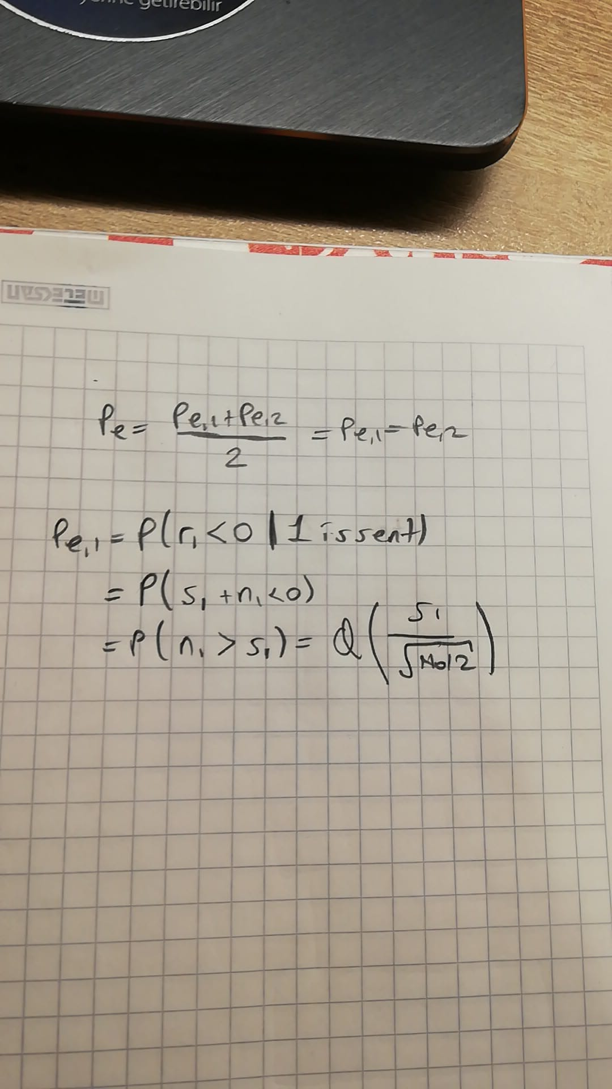

Figure 2.4.2 The theoretical probability of bit error (s1 is the signal’s representation in the signal space)

In MATLAB, the following error formula was used (which is equivalent to the previous one):

|  |  |  |
| --- | --- | --- |
|  |  |  |

(e)



Figure 2.5.1 Probability of bit error vs. SNR

Discussion

In Figure 3.5.1, the dots represent the probability of bit error for the optimal receiver experimentally for specific variance values. However, the blue curve represents the theoretical probability of bit error for given SNRs. Since the dots coincide with the curve, we can say that the optimal receiver works as we have expected. As we increase the SNR, the probability of bit error decreases.

(f) The receiver in part (d) is still optimal, except for one part. Since the bits are not equally likely, we cannot continue using the ML rule. We must switch to MAP rule. This corresponds to the change of the decision threshold. Other than the statistical estimation part, we can continue using the same correlation device.

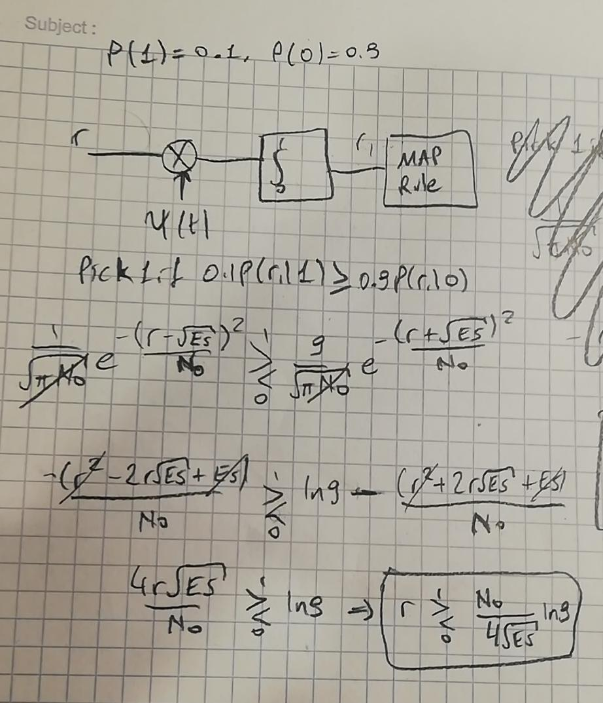

Figure 2.6.1 Optimal receiver with MAP rule

(g)



Figure 2.7.1 Probability of bit error (PoBE) vs. SNR (Blue line shows theoretical ML PoBE, stars show experimental ML PoBE, and circles show experimental MAP PoBE)

Discussion

As it can be seen in Figure 2.7.1, MAP decision rule minimizes the probability of error if the prior probabilities are known. MAP errors are quite lower than ML errors. In the receiver, the decision threshold was optimized for input distribution with MAP rule.

(h)



Figure 2.8.1 Probability of error comparison between ML and MAP decision rules. Variance of the noise is 0.01.

Discussion

If the prior distribution is known, MAP performs better than ML as it can be seen in Figure 2.8.1. However, if the prior distribution is not known, i.e., outcomes are equally likely, MAP rule performs same as the ML rule. As the α approaches to 0.5, performances of MAP and ML also get closer.

**Part III: Frequency Shift Keying**

(a)



Figure 3.1.1 x(t) for the following 5 random symbols: "00" "11" "01" "11" "01".

(b)



Figure 3.2.1 First basis function.



Figure 3.2.2 Second basis function.

The dimension of the signal space is 2 because the set of signals is a bi-orthogonal one.



Figure 3.2.3 Representation of s1(t) on the signal space.



Figure 3.2.4 Representation of s2(t) on the signal space.



Figure 3.2.5 Representation of s3(t) on the signal space.



Figure 3.2.6 Representation of s3(t) on the signal space.

(c)



Figure 3.3.1 The original and the received signal, variance is 0.01.



Figure 3.3.2 The original and the received signal, variance is 1.



Figure 3.3.3 The original and the received signal, variance is 100.

Discussion

Theoretically, the SNR is given as Es/N0. However, this definition is only true for an ideal white noise process. Since we are not able to cover the whole spectrum of the noise, depending on the sampling rate, the spectral density of the white Gaussian noise will be bandlimited. The exact amount is Fs/2, where Fs is the sampling rate. So, as long as we increase the sampling rate, the SNR will go up because the spectral density is N0B/2, where B is the bandwidth of the spectral density.

(d)

metin, iç mekan içeren bir resim

Açıklama otomatik olarak oluşturuldu

Figure 3.4.1 Optimal receiver and the ML rule

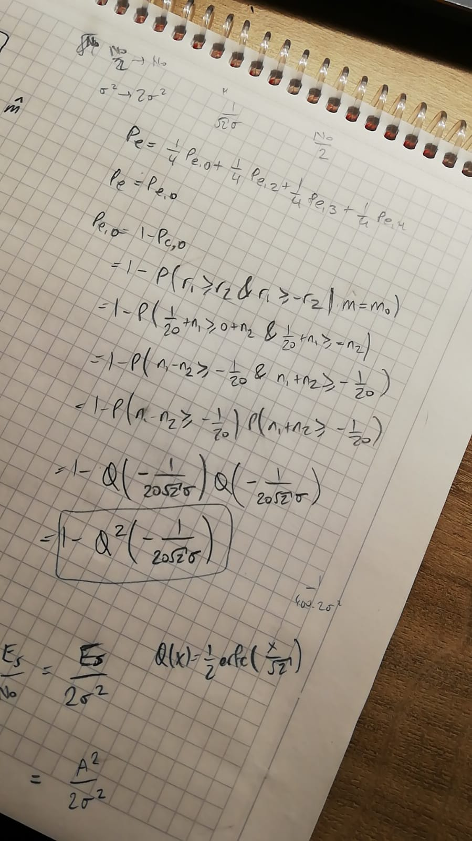

Figure 3.4.2 Probability of symbol error in theory.

In practice, I used the following formula for the theoretical error:

|  |  |  |
| --- | --- | --- |
|  |  |  |

(e)



Figure 3.5.1 Probability of symbol error vs. SNR.

Discussion

In Figure 3.5.1, the dots represent the probability of symbol error for the optimal receiver experimentally for specific variance values. However, the blue curve represents the theoretical probability of symbol error for given SNRs. Since the dots coincide with the curve, we can say that the optimal receiver works as we have expected. As we increase the SNR, the probability of symbol error decreases.